**Remote Engine Installation Implementation**

**Talend Remote Engine 2.12.9**

**Installation Guide & Documentation**

**Contents**

**Section 1: Introduction** 3

**Section 2: Prerequisites** 4

**Section 3: Installation** 5

**Section 4: Configuration** 7

Approval

| Signatures by each signatory indicate their acceptance that this document is complete and accurate to the best of his/her knowledge per responsibilities outlined in this document and as guided by approved methodologies and established procedures. | | |
| --- | --- | --- |
| Developer:  Artha Consultant | **Subhransu** | **Date:** |
| Project Manager:  Artha Consultant | **Rajesh Bharadwaj** | **Date:** |
| Architect:  Artha Consultant | **Rama Krishna** | **Date:** |

# **Section 1: Introduction**

Remote Engines allow you to run tasks that use on-premises applications and databases. Outbound communication between Talend Cloud Management Console and Remote Engines is fully secured as data is not staged. Data Service and Route tasks can only be deployed on Remote Engines.

If you are using a Remote Engine to run identical tasks simultaneously, your Remote Engine must be v2.12.0 onwards.

Data service and Route tasks can only be deployed on Remote Engines.

**Installation Environment**

DEV Environment

# **Section 2: Prerequisites**

**Login into Talend Cloud**

a. Check the specific region

b. Click on the user mail

c. Click on Downloads

**Goto Talend Remote engine**

i. Check Installer for linux (run) file and latest version

**Download the Linux run file**

Install compatible java version

cd /usr/lib

mkdir jvm

Give full permission to jvm folder

wget https://www.oracle.com/in/java/technologies/javase/jdk11-archive-downloads.html#license-lightbox

(or)

#Download from: - https://bell-sw.com/pages/downloads/

#extract the java file

tar -xvf jdk-11.0.17-linux-x64.tar.gz

#set the java path

cd /etc/profile.d

sudo vi jdk.sh

export JAVA_HOME=/usr/lib/jvm/jdk-11.0.18

export PATH=$JAVA_HOME/bin:$JRE_HOME/bin:$PATH

#reboot or restart the server to check java version

java -version

**Section 3: Installation**

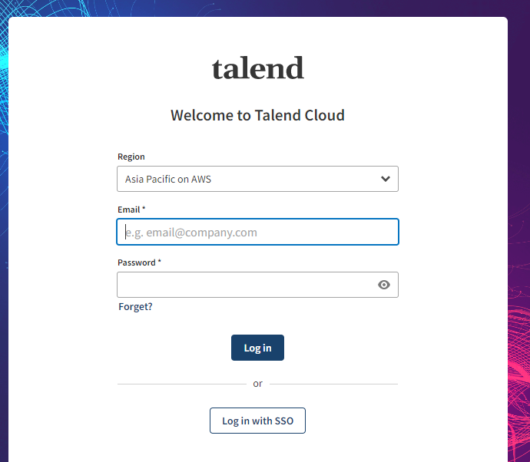

**Goto Download section**

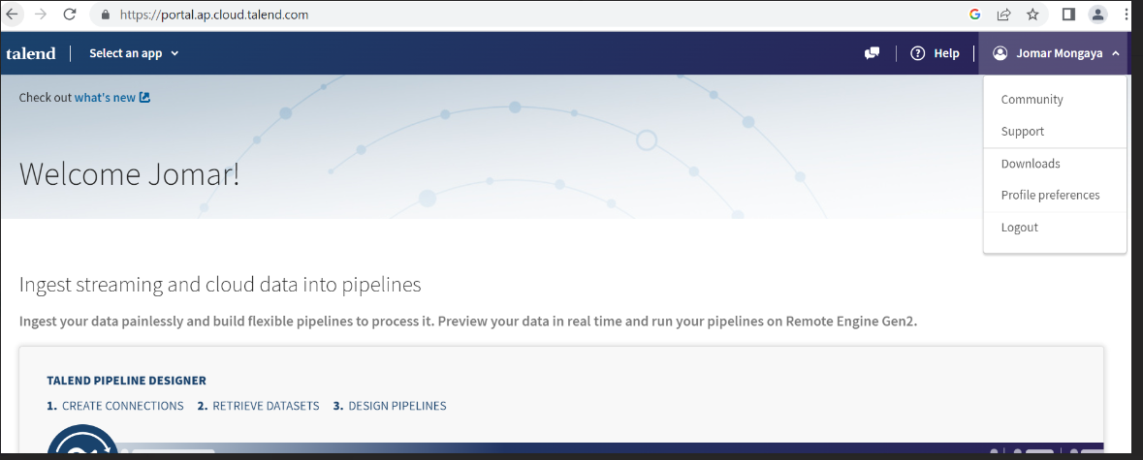

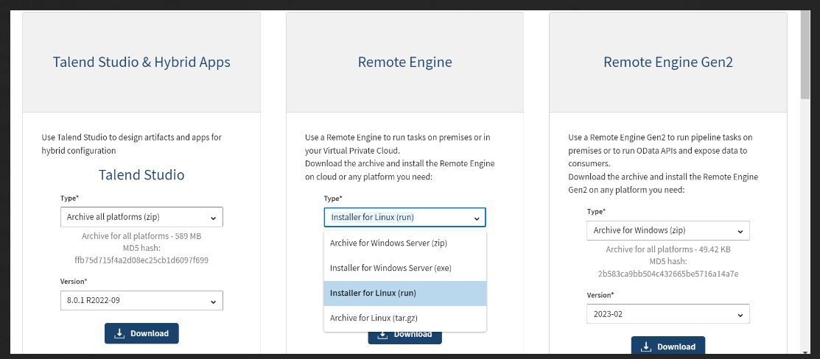

#goto the linux terminal

mkdir Remote-Engine

Cd /opt/Remote-Engine

#copy the Talend-RemoteEngine-V2.12.9-254-Linux-x64.run file from localhost to linux terminal

i)Use winSCp

#Give the permissions to the .run file

chmod –R 777 Talend-RemoteEngine-V2.12.9-254-Linux-x64.run

#Goto the Talend cloud

i) Select an app

ii) Management console

iii) Engines

iv)Add remote engine

v) Create a new remote-engine and save it

# **Section 4: Configuration**

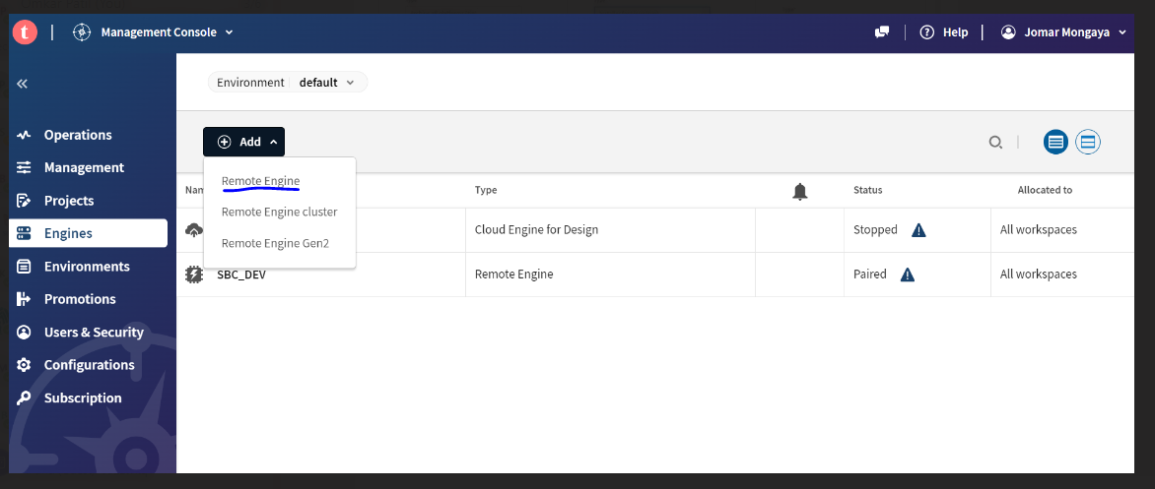

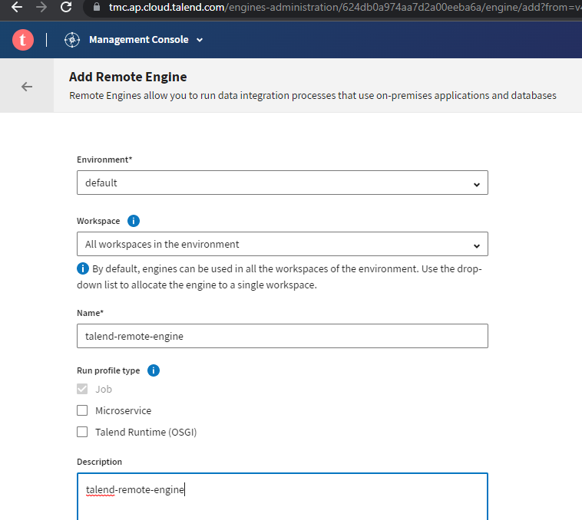

#goto linux terminal Install the remote engine

./Talend-RemoteEngine-V2.12.9-254-Linux-x64.run

(or)

## if want to install on single command ##

./<installer_filename> --mode unattended --installdir /opt/TalendRemoteEngine --region <xxx> --authkey

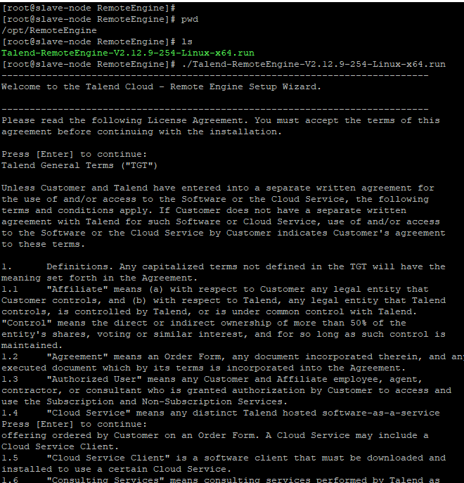

#Pre authorized key is on the Talend Cloud remote engine

i) Copy the preauthorized key and paste it

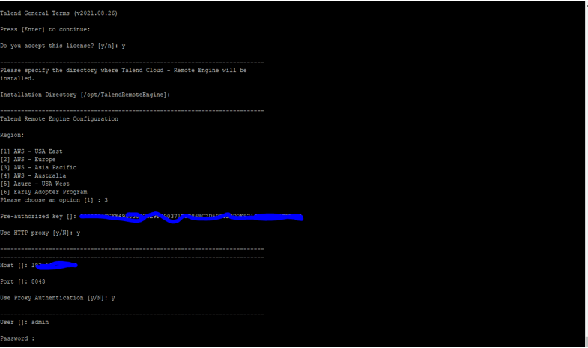

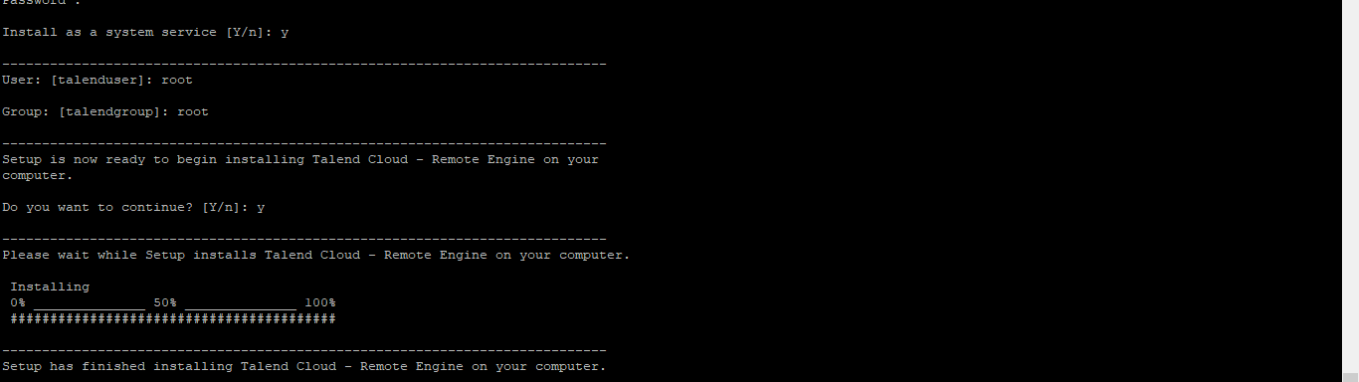

* systemctl status talend-remote-engine
* systemctl start talend-remote-engine
* systemctl stop talend-remote-engine
* systemctl restart talend-remote-engine

#goto the talend remote engine installed path/directory

cd /opt/TalendRemoteEngine

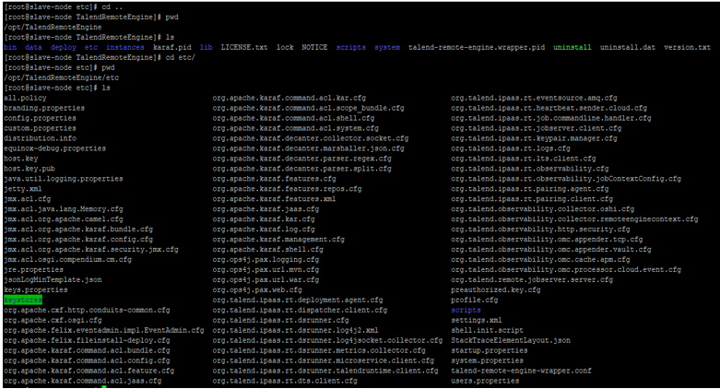

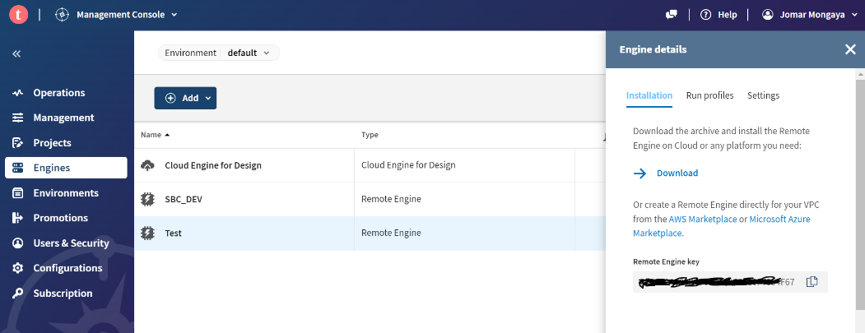

#stop the talend-remote-engine

systemctl stop talend-remote-engine

#configure the changes

vi org.ops4j.pax.web.cfg

#change the configuration

org.ops4j.pax.web.listening.addresses=<ip address>

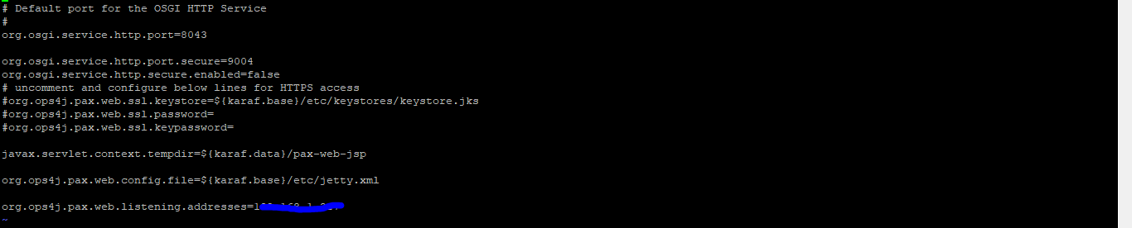

#restart the talend-remote-engine

systemctl start talend-remote-engine

systemctl restart talend-remote-engine

systemctl status talend-remote-engine

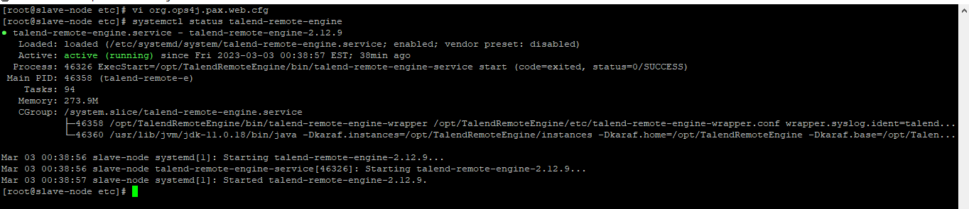

#goto web browser and acces the remote engine

http://<ip-address>:8043/configuration

